Critical Design Review

2nd team of Rocket Parachute Delivery System

-R2D2-

2015. 06. 30

이진희, 지현배, 오주안

이강규, 차영돈, 이영준

유승준, 박용준, 윤예본

1. Contents

**Introduction** **1**

Requirements 2

**Body** **4**

Aerodynamic Analysis 4

Propulsion Design 9

Structural Design and Analysis 17

Structural analysis using Midas NFX – main wing 18

Structural analysis using Midas NFX - fuselage 20

Control system design 25

**Conclusion** **28**

Configuration of R2D2 29

**Reference** **30**

1. Introduction
   1. Requirements
      1. Need for research and developments

Was started in December 2013 Guinea "West Africa Ebola outbreak". It is to produce a large tragedy of human history around the three countries of Sierra Leone, Liberia, Guinea. To prevent the spread of Ebola, World Health Organization (WHO) has established a virus epicenter facing the border of the three countries quarantine area. But the problem is not the only Ebola. Relief supplies transmission such as groceries is not normally performed in quarantine, are increasing cases of violation of the insulation guidelines. Limits the movement of people in an isolated area, it is not possible to go freely even vehicles and diffusion rate of Ebola is too fast not keep up the article for Measures to Support.

As in the globally technical capabilities development, virus, disaster and war are also constantly followed. From these, indispensable for these areas is the replenishment rapid supplies. Goods support system to date has been made through the use of a vehicle or aircraft parachute. However, the vehicle is limited to the activities in the disaster area or virus isolation area. Therefore, support system is a quick and accurate, must be even cheaper operating costs.

* + 1. Goal of the research and development

Rapid back support system is intended to develop a virus quarantine, disaster areas or battlefield area quickly and accurately to hold an article support capability initial takeoff aircraft using rockets and jet engines.

Collect the relevant technical data for the development of aircraft that can meet the performance requirements of these rapid logistics system is analyzed, is carried out first conceptual design. The data obtained via the technical data analysis similar systems by applying the theoretical equation to establish the operational concept. It also quickly estimate the shape and performance of the basic aircraft . Also, analysis method that can meet the performance requirements, design criteria, and a production direction provides.

### Final requirements

Our payload’s final requirements

|  |  |  |  |  |  |
| --- | --- | --- | --- | --- | --- |
| Chocolate bar | Water | Combat ration | Aqua tabs | Parachute | First-aid kit |
| 0.8kg | 12kg | 3.6kg | - | 5.5kg | 1.4kg |
| 600 | 12000 | 28500 | 130 | 7300 | 1920 |
| Total Volume : 50075 | | | | | |
| Total Weight : 23.3kg | | | | | |

R2D2’s Requirements

|  |  |  |  |  |  |
| --- | --- | --- | --- | --- | --- |
| Payload(kg) | | Total weight(kg) | Cruise Speed(m/s) | | |
| 23.3 | | 50 | 69 | | |
| Duration of flight(min) | Range(km) | Altitude(km) | Control | Rate of sink(m/s) | Landing Error(m) |
| 8 | 35 | 2.76 | Automatic control system using GPS | 5.9 | 550 |

1. Body
   1. Aerodynamic
      1. Lift curve

Using R2D2’s Wing-body-tail combined data, we can draw lift curve like this picture.



Figure 1 alpha-C_L graph

R2D2’s Stall angle is 20 degree,  is 1.70, Zero-lift AOA goes –0.75˚.

* + 1. Drag polar



Figure 2 C_D - C_L graph

As you can see in Figure 2, goes 0.0340.

* + 1. Longitudinal stability

We can get a data from DATCOM, and checked R2D2’s longitudinal stability.

graph for checking longitudinal stability is shown in Figure 3.



Figure 3 C_L-C_M Graph

As you can see in Figure 3, static margin goes about 12%.

In R2D2’s case, it’s not actual airplane size when it comes to manufacturing, considering normal aircraft’s S.M is 0~10%, we can check this is appropriate value of S.M.

* + 1. Directional stability

We checked Directional stability according to sideslip angle.

Aircraft is stable when .

We can check our directional stability is stable considering R2D2’s DATCOM data of



* + 1. Lateral stability

In lateral stability, Aircraft is stable when <0.

Table 1. shows values of according to sideslip angle.

|  |  |  |  |
| --- | --- | --- | --- |
|  |  |  |  |
| -4 | -1.68E-05 | 14 | -2.00E-03 |
| -2 | -2.34E-04 | 15 | -2.07E-03 |
| 0 | -4.40E-04 | 16 | -2.13E-03 |
| 2 | -6.53E-04 | 17 | -2.17E-03 |
| 4 | -8.78E-04 | 18 | -2.19E-03 |
| 6 | -1.11E-03 | 20 | -2.18E-03 |
| 8 | -1.35E-03 | 22 | -1.90E-03 |
| 10 | -1.60E-03 | 23 | -1.59E-03 |
| 12 | -1.83E-03 | 24 | -1.32E-03 |

Table 1

As we checked this chart,  goes minus value which means it is stable through all AOA.

Figure 4 shows our simple design using missile DATCOM and our calculated data.

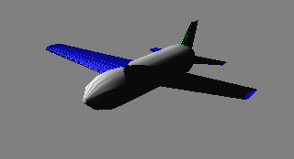

Figure 4 R2D2 Figure

* + 1. High Lift Device & Control Surface Sizing

R2D2 uses plain flap in horizontal tail wing to get more lift when it is flying.

- Elevator

Generally, elevator will be located from body to end of the wing. or 90% of the wing.

Also, in historical trend’s case, it is as big as wing chord’s 25~50%.

In R2D2’s case, we decided 70% of horizontal tail is elevator’s part for trim.

- Trim Chart

In R2D2’s cruising, trim chart is shown below. As you can see in this picture, when elevator’s deflection angle is bigger, curve’s change goes smaller.

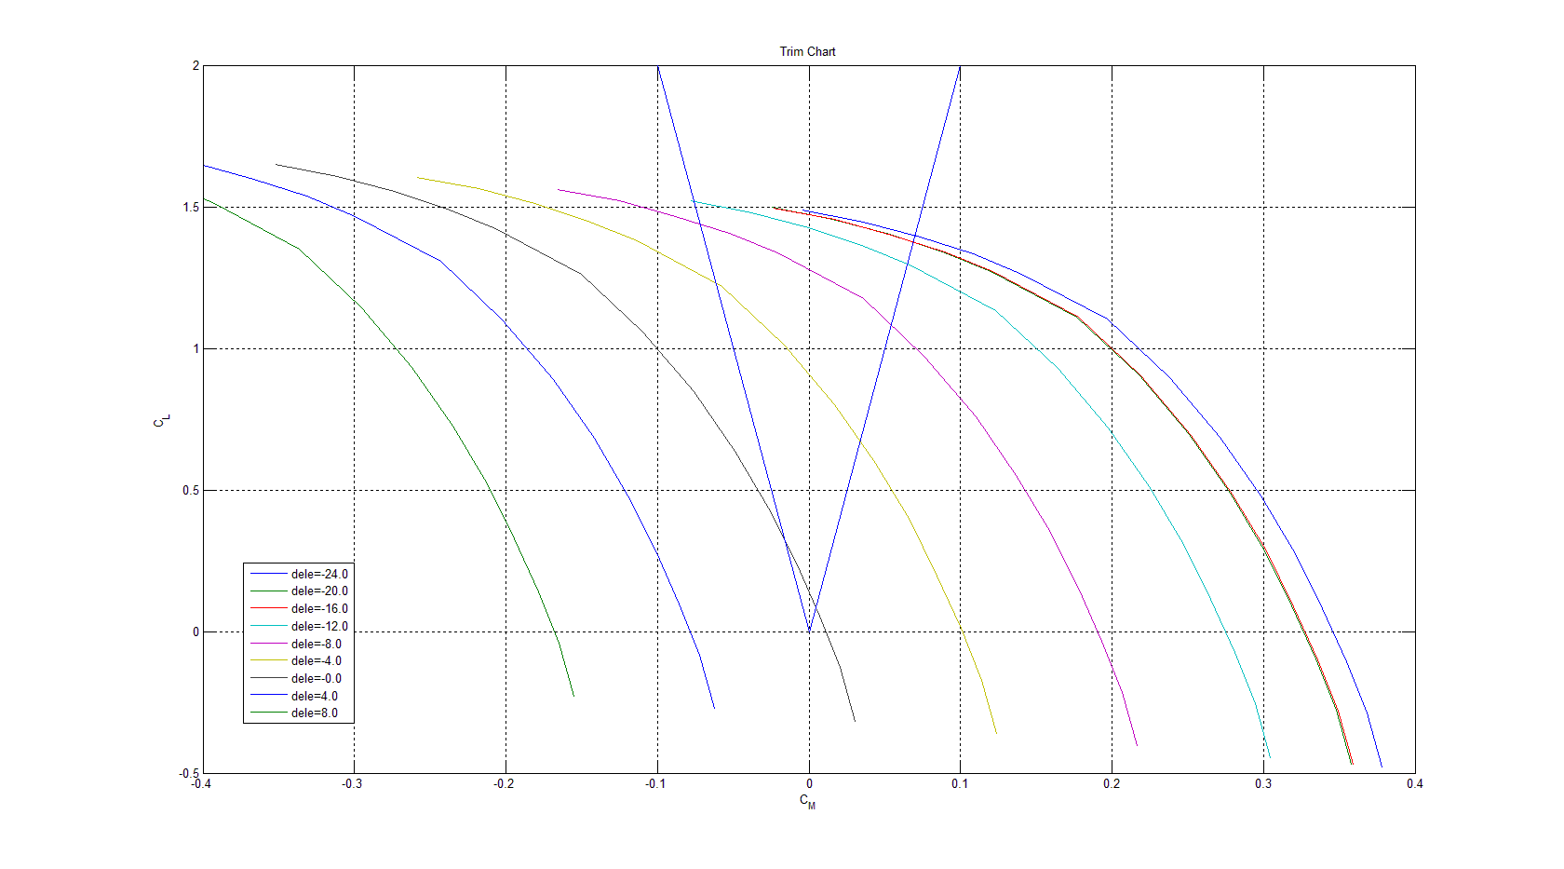

Figure 5 Trim Chart

R2D2’s maximum lift coefficient is 1.7. but when you see in the graph, you can’t get trim in maximum lift coefficient’s case. we can give elevator’s deflection to get  closer to trim. but this is not exact value. To get exact trim, we need more devices. but since R2D2 is disposable device, we thought it is enough since we could get lift coefficient for mission.

|  |  |
| --- | --- |
|  | 1.7 |
|  | 0.0340 |
| Static Margin ( ) | 11% |
| Directional Static Stability | : Sable |
| Lateral Static Stability | < 0 : Stable |

* + 1. Rate of sink

an calculate Rate of Sink using these equations when Aircraft is gliding



Next, calculate the drag term. 

Drag Coefficient,  we get from DATCOM.

Oswald Span Efficiency, e



R2D2 has 10° of sweep angle. And 5.2 of Aspect Ratio. So,



Next, Lift Coefficient,

 

,  are functions of velocity.

P (Power) can be expressed,, when gliding T(Thrust)=0 ,

SO, D is function of velocity. And P also function of velocity. 

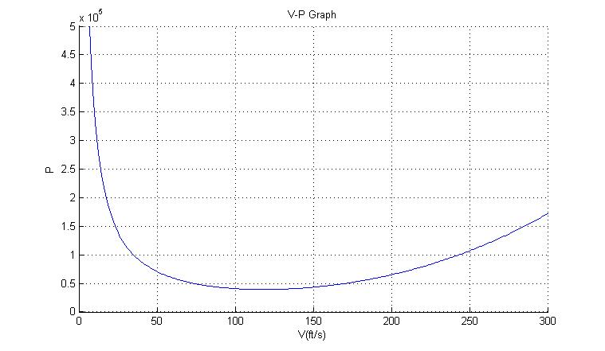

Figure 6 V-P Graph

Next, Rate of Sink. 

Using This Equation, Figure 7 is V-RS Graph

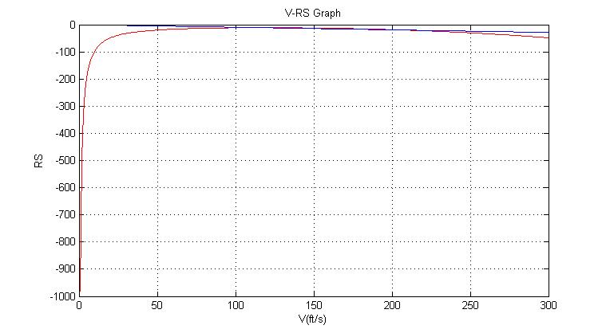

Figure 7 V-RS Graph

In Figure 7, when glide, V=153ft/s and Descent angle is 5.14°

So, we can get mission altitude as h = 2250m and RS = 4.2m/s.

Then, mission time can be calculated like,



|  |  |
| --- | --- |
| Velocity | 46.63m/s |
| Altitude | 2250m |
| Descent angle | 5.14 degree |
| Rate of Sink | 4.2m/s |
| Mission Time | 9 minutes |

* 1. Propulsion
     1. Thrust

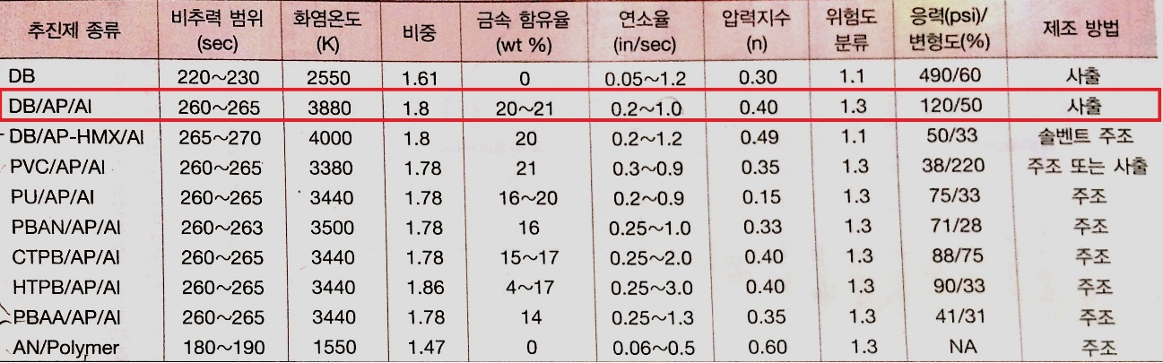

Isp=260 Complex double base that has Isp=260 is chosen by propellant.

R2D2’s Mass that include propellant is 50kg. after burn out propellant, this mass decrease to 40kg. burn out time is 20sec and angle of fire is 45 degree. Effective Exhaust velocity is 2511.6m/s

**Altitude Calculation**

After burn out projectile velocity & altitude is calculated by using below formulas.





In this formulas, we assume drag is got in maximum velocity.

Drag is calculated by using cd& area data got by Datcom.



Finally we can get projectile velocity 111.84m/s and after burn out Altitude is 2123m.

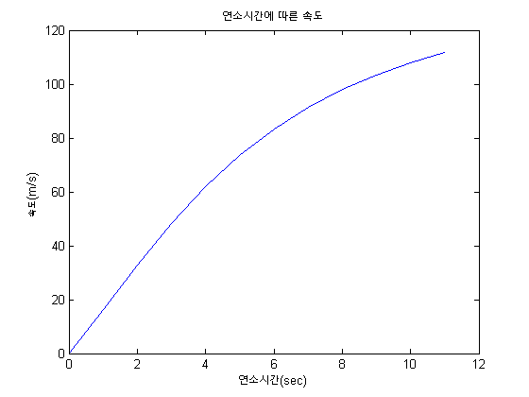

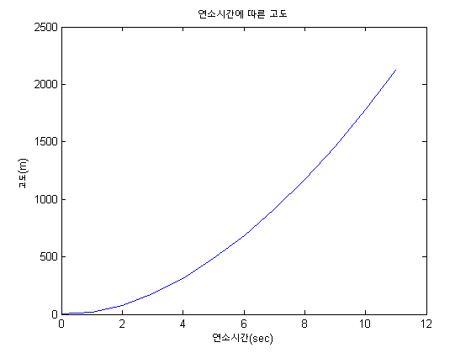

Also maximum Altitude is 2760m using 

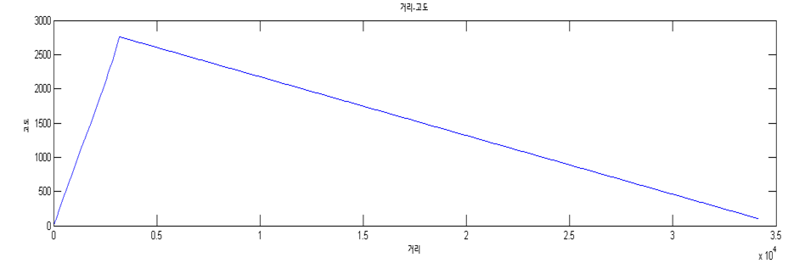

We’ve calculated the time between hb and hmax considering altitude difference, ub’s vertical velocity, drag and vertical velocity of maximum altitude. And then, we calculate final glide speed using ub’s horizontal speed and drag.

Calculated glide speed is 69m/s(M=0.2).

**Thrust calculation**

Because We already calculate mass change and burn out time, we can get =0.9091kg/s by using . in this mass flow rate, we can calculate thrust F=773.3N * 3 to 

|  |  |
| --- | --- |
| Maximum Altitude | 2760m |
| Thrust | 773.3N * 3 |

* + 1. Grain Design

The volume of propellant grain is 0.001 * 3

The grain shape was determined by a simple cylindrical.

Therefore, retreat ratio and burn rate are equal to each other and we can calculate web thickness from this equation , that is 27.94cm.

Now, we know about V,b, so we can calculate Db= 9.2cm

* + 1. Nozzle Design

In order to obtain the chamber pressure

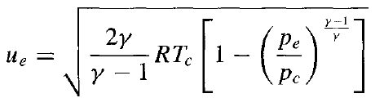



Use the above formula.

It is assumed in the R and, respectively 287 and 1.3 , Use the following formula to obtain a thrust coefficient.

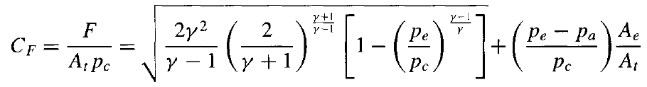

For an ideal nozzle, the nozzle outlet pressure equal to the atmospheric pressure.

Therefore, assuming that the pe-pa = 0

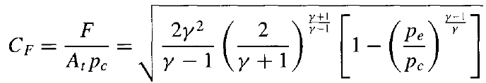

Simplified as shown above. Therefore, Thrust coefficient is 1.588.

Now, the nozzle throat Area is calculated by this equation and that is 0.0005



and diameter is 0.008m.

The rising speed was substituted in the appendix-A to save the nozzle exit area.

An area ratio obtained from this.

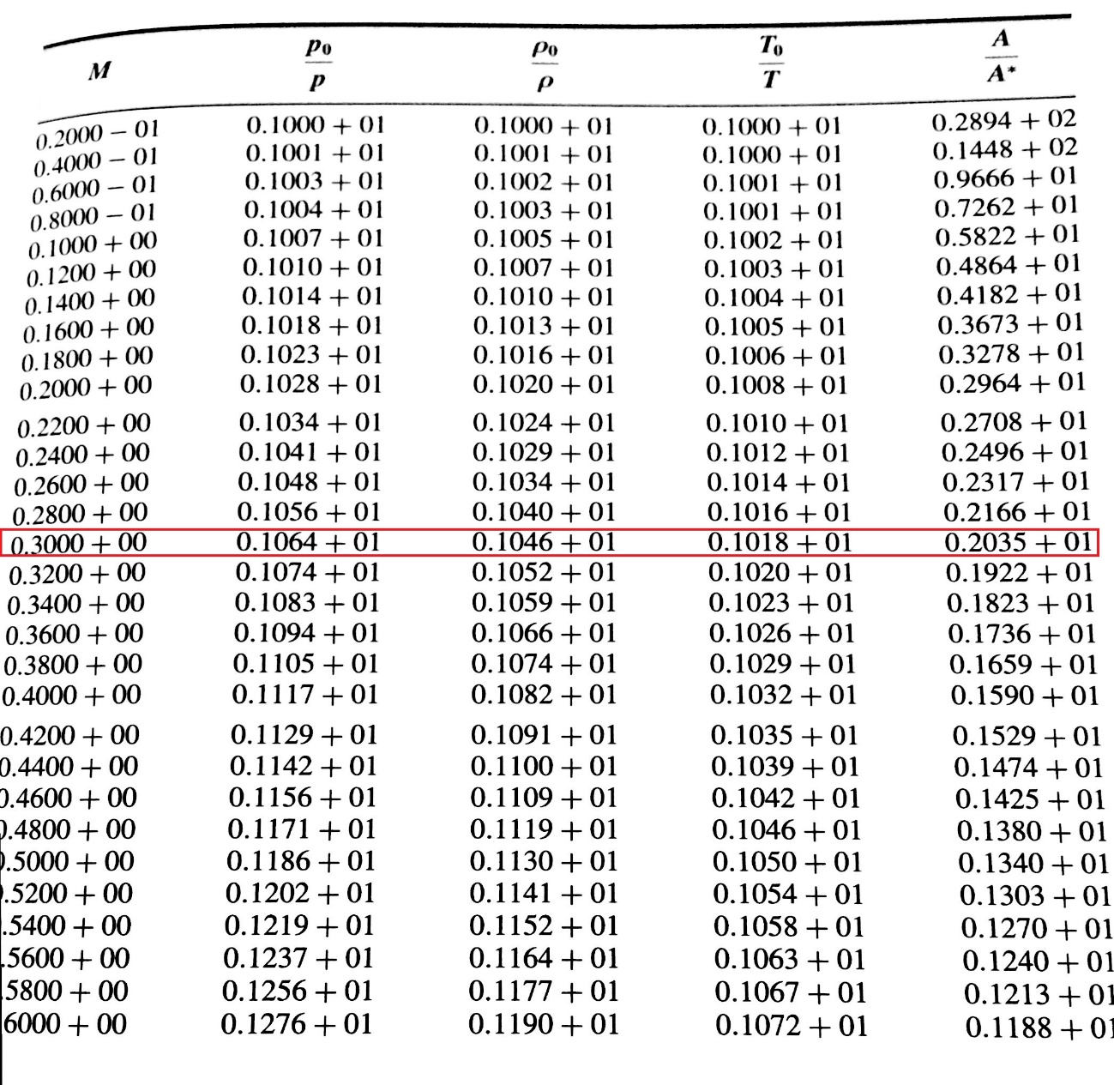

Therefore, using this equation



The nozzle exit area is 0.00009887 and diameter is 0.0012m.

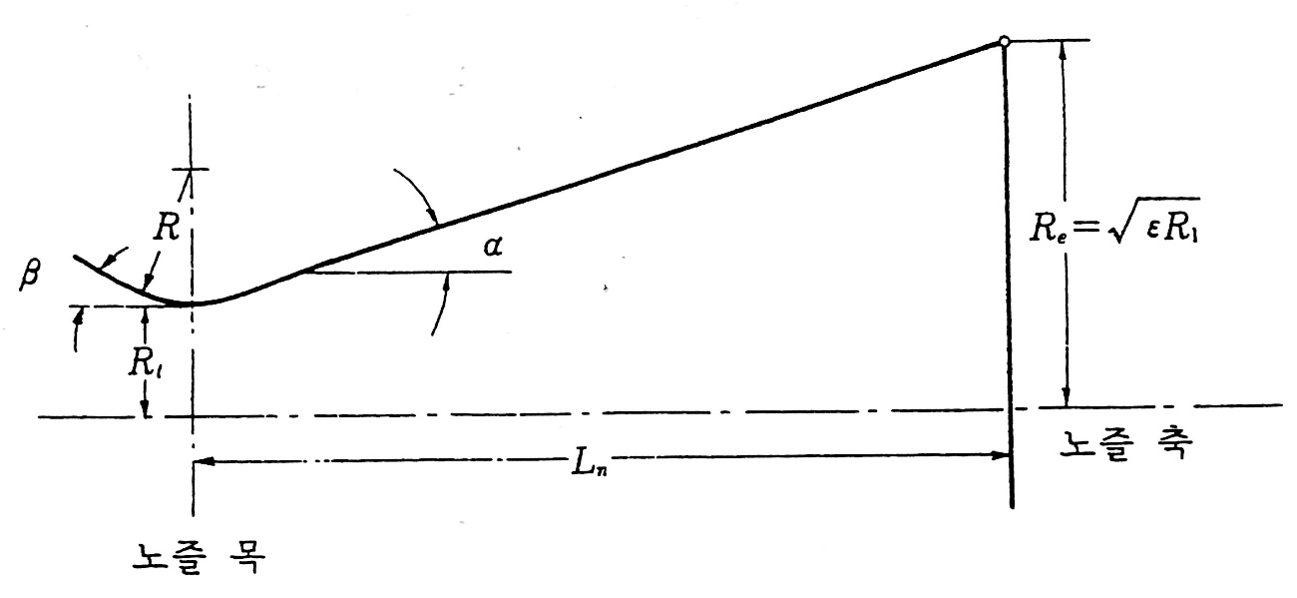

Figure 10 Nozzle design

Assuming as a , ,and calculates Nozzle length that is 0.0149m



* 1. Structure
     1. Wings structure

Determine the number of rib.

The R2D2 system has main wings. And the lift force is distributed on the wing skin that transfer the force to spar and ribs. and the main wings’ span is 1500mm from the Datcom.

The maximum lift of R2D2 is about 750N at maximum velocity. So we convert this force to distributed force as



Then the distributed force is applied to the wing’s upper skin. But we should consider the safety factor. So we assume the distributed force is 500N on each wing.

Next we assume the each wing with 3 spars and 10 ribs and structure’s thickness 3mm and skin’s thickness 1mm. After that we analyze this wing by using NFX. But it isn’t efficient. So we gradually decrease the number of ribs. Finally we decide the each wing with 3 spars and 6 ribs.

Below data represents our wing’s displacement and stress.

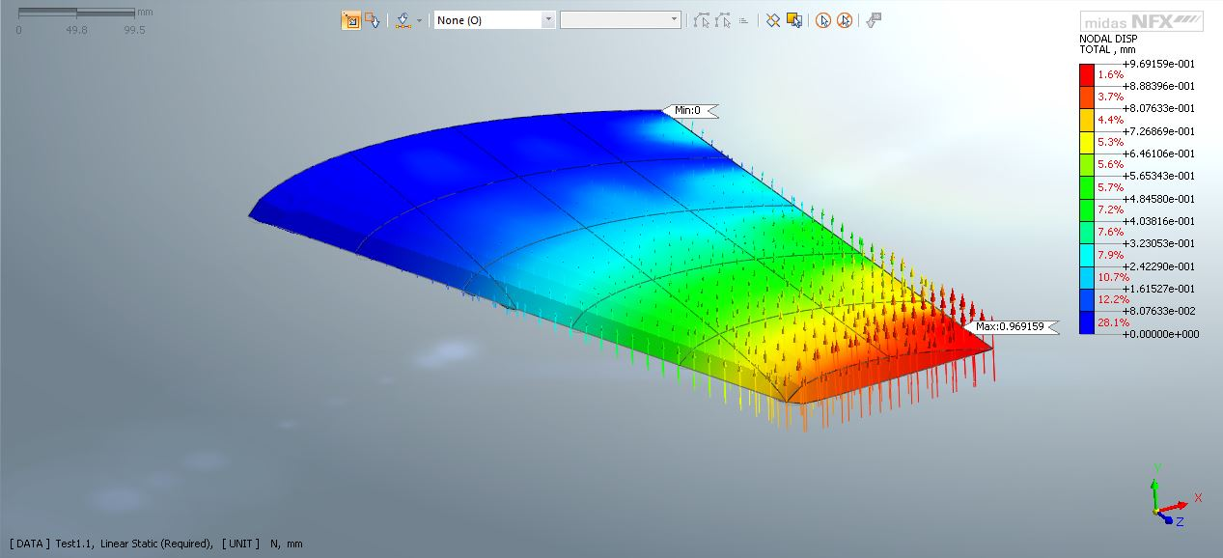

Figure 8 Displacement

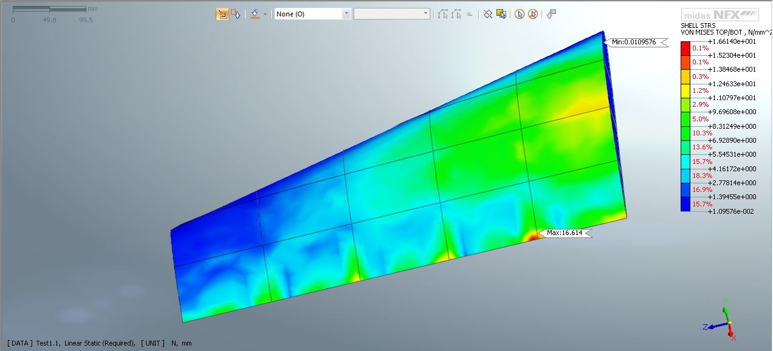

Figure 9 Maximum stress

upper data shows that in case of displacement, wing tip has maximum value, this result is reasonable because this tendency can be founded easily from general case in aircraft.

As you know aluminum 7075-0 has maximum ultimate tensile strength no more than 275 MPa, and maximum yield strength no more than 145 Mpa, because 16Mpa that is maximum stress in our wing is less than that value, we can conclude our wing is safty. For the sake of convenience we use spars and ribs shaped rectangular beam, actually we will use the spar as I-beam.

Fuselage Design and Analysis

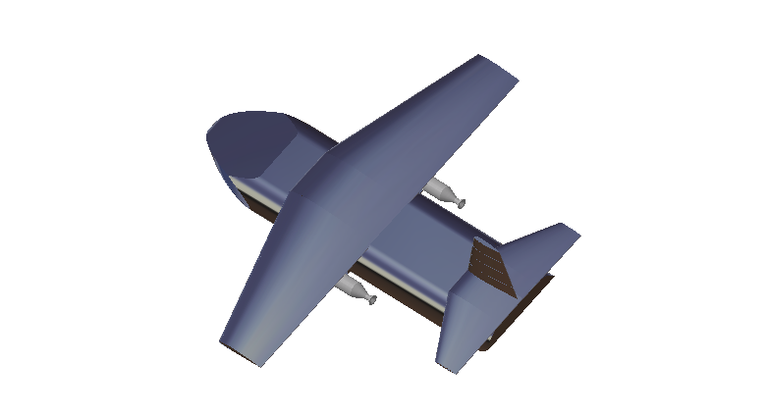

Figure 1.

As you can check in Figure 1. We decided the length and cross sectional area based on the volume of payload. Fuselage volume which designed before is about 62,000. So the volume for payload and parachute is 50,000 and the volume for other components plus margin is around 12,000. As a result, the length of fuselage is 140cm, 38cm of width, and 18cm of height.

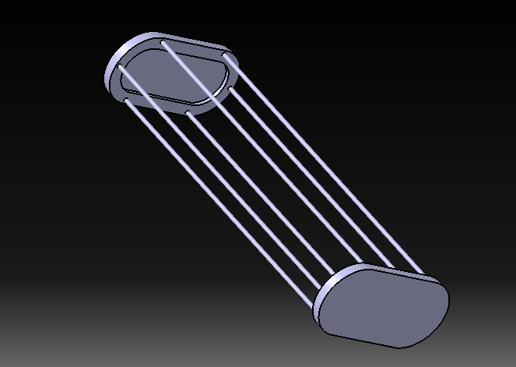After considering the outer line, we decided the inner structures which are ribs, stringers, and partitions. Firstly, we decided the number of each structures and thickness. And we analyzed using Midas NFX whether these structures can endure for the forces which are calculated from aerodynamic analysis.

Firstly, we decided the number of stringers and those thickness.

You can check the number of stringers is six from the Figure 2. And we decided the thickness of each stringer is 5 mm.

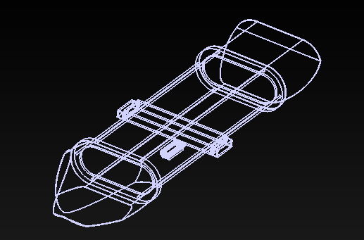

Figure 3. Partitions

You can recognize there are two partitions which are located in front and rear of fuselage. We put these partitions as inner structures. The number of partitions are two and we decided the thickness of each partition is 25 mm.

As we decided the specifications of each structures, these should be analyzed whether they can endure stresses or how much they will be displaced. So we analyzed using Midas NFX.

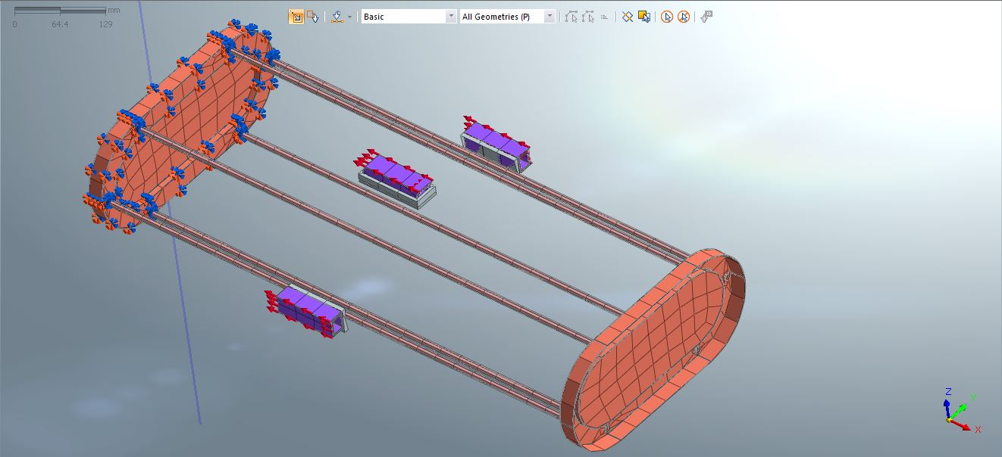

As you can see in Figure 4. We applied constraints to front partition and applied forces to the areas which will be located the rocket propellants. We decided the number of rocket propellants is 3 and the thickness of each pylon is 5 mm.

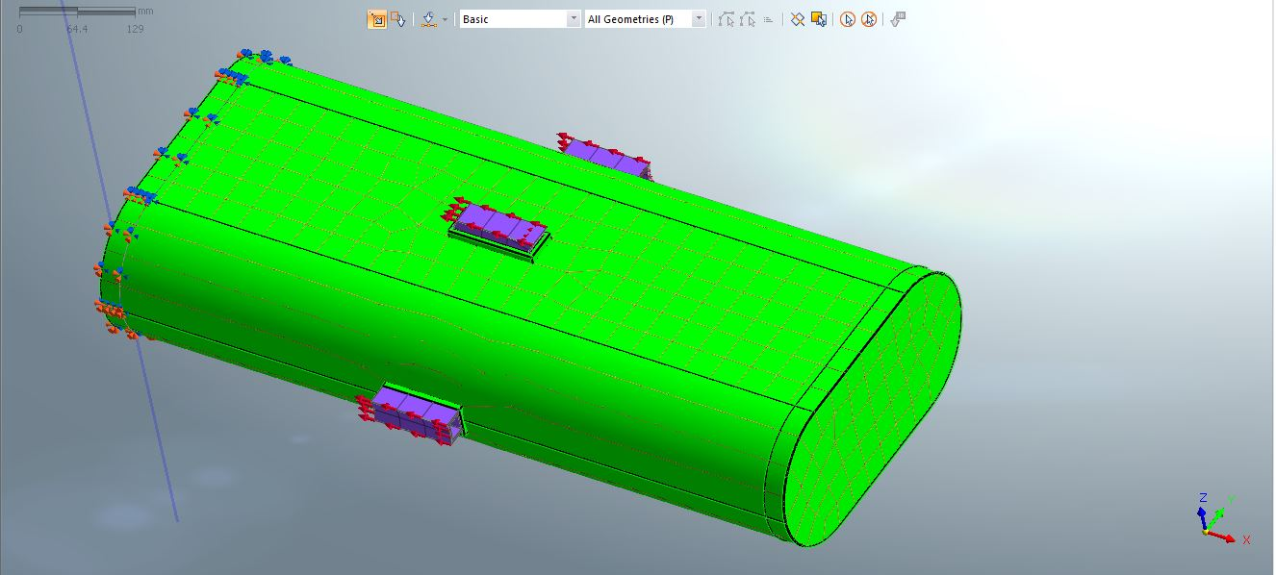

Figure 5. shows the model which contains stringers and skin. We estimated the thickness of skin is 1 mm.

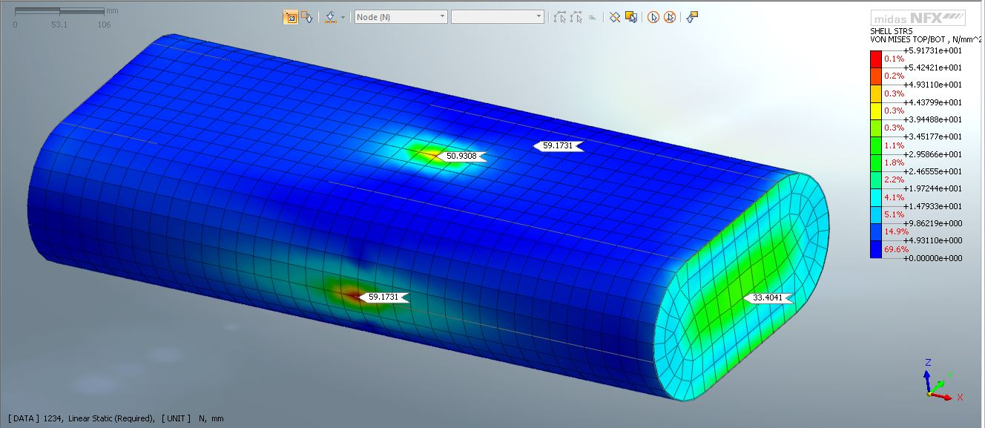

Figure 6. shows the result of structural analysis. We choose the Aluminum 7049 alloy as materials of structures. The von mises stress of aluminum 7049 alloy is 482.5 which you can check from Figure 7.

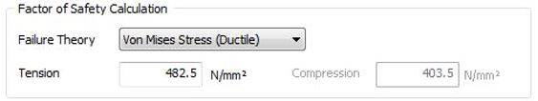

Figure 7. Von mises stress of aluminum 7049 alloy

The calculated von mises stress from Figure 6. Is 59.1731 to each pylon and 33.4041 to rear partition. As the von mises stress of aluminum 7049 alloy is 482.5 , this designed structural model is reasonable.

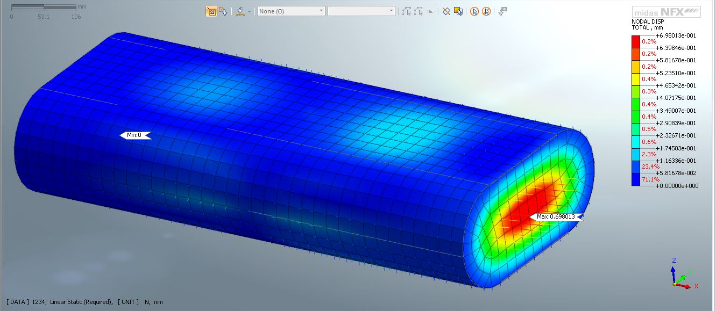

Figure 8. Displacement

Figure 8. shows the displacement of the fuselage. The maximum displacement is around 0.7 mm of rear partition.

As we analyzed these structures which we designed, we can calculate the total weight of fuselage which contains two partitions and six stringers is 10.88 kg.

Table 1. shows the specifications of each structures

|  |  |  |  |
| --- | --- | --- | --- |
| Structures | number | thickness | Weight |
| Main Body | 1 EA | 1mm | 1.43 kg |
| Nose | 1 EA | 1mm | 0.47 kg |
| Tail | 1 EA | 1mm | 0.73 kg |
| Propellant Case | 3 EA | 1mm | 1.523 kg * 3 = 4.6 kg |
| Stringer | 6 EA | 5mm | 0.1 kg * 6 = 0.6 kg |
| Partition | 2 EA | 25mm | 1.21 kg * 2 = 2.42 kg |
| Pylon | 3 EA | 5mm | 0.21 kg * 0.36 kg |

Table 1. Fuselage structures

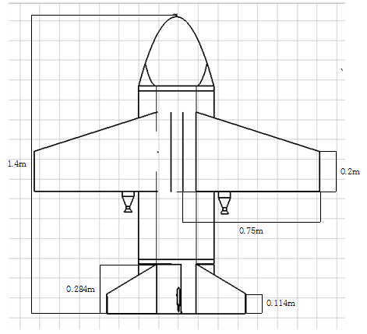

Figure 9. R2D2 configuration

* 1. Control
     1. Stability Control

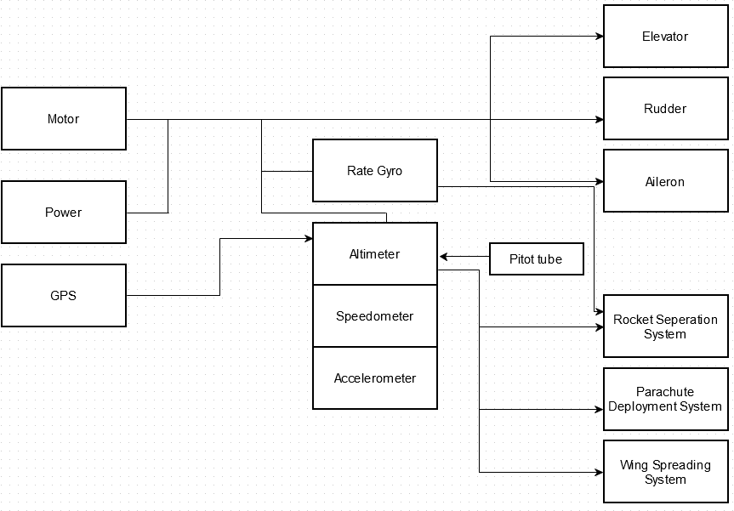

When R2D2’s gliding is proceed, we need R2D2’s position control. We need to control elevator, rudder, aileron to control R2D2’s gliding.

First, parameters that we need in moving elevator are , u, (w), q(pitch angular velocity), (pitch angle). Second, parameters that we need in moving rudder and aileron are v(), , p(roll angular velocity), r(yaw angular velocity), (roll angle), (yaw angle).

Each parameter’s calculation method goes like this. Since is wind speed, we can calculate this value through pitot tube. u, v, w is measured speed, we can calculate these values using speedometer. Angular velocity(p,q,r) and Angle( are calculated by rate gyro.

R2D2 also needs rocket separation control system, wing spreading system, parachute deploy system.

Elevator is an important control device for static longitudinal stability. To activate elevator, we need parameters such as , u, (w), q(pitch angular velocity), (pitch angle). And we also need power supply and motor. We can get elevator’s angle using these values.

Rudder and aileron are devices for aircraft’s tranverse stability. Rudder&aileron need v(), , p(roll angular velocity), r(yaw angular velocity), (roll angle), (yaw angle). And we also need power supply and motor. We can also calculate these values and measure change of rudder and aileron’ s angle.

And we have to check R2D2’s dynamic stability. First, longitudinal stability’s Characteristic Equation goes like this.

Therefore, This picture shows R2d2’s Phugoid period mode of longitudinal stability.

As you can see, this picture shows that our system is stable

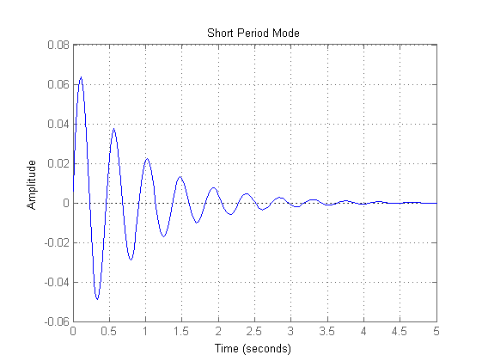

And this is Short period mode of longitudinal stability, its also stable.

Next, we need to check lateral stability.

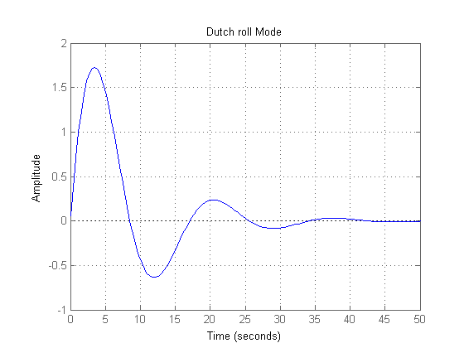

This picture shows dutch roll mode of lateral stability.

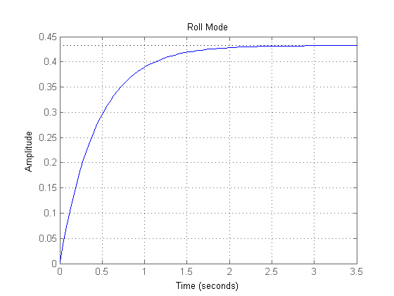

And this is roll mode of lateral stability.

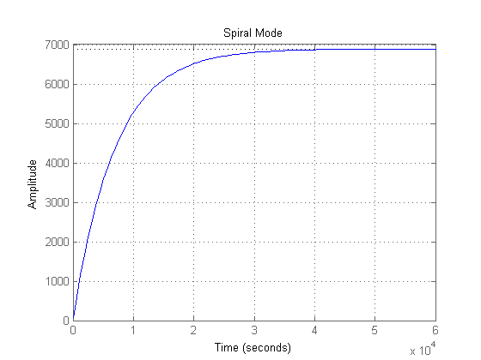

And this is spiral mode of lateral stability. As you can see in those pictures, It is stable for R2D2.

* + 1. Control Systems we need in R2D2
       1. Rocket separation control

Parameter we need in rocket separation is altitude(h), its control system activates same time with wing spreading. Since we got altimeter in our control system, Altimeter can determine altitude.

* + - 1. Wing deployment control

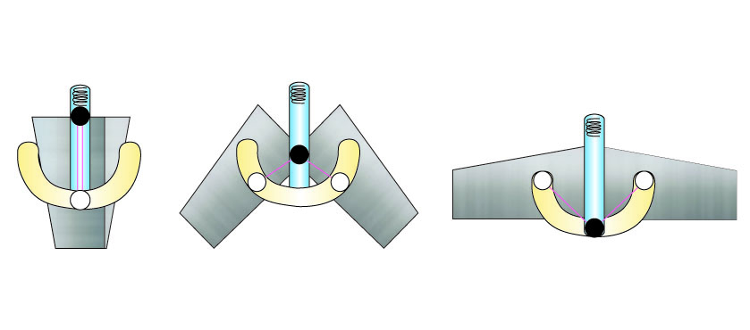

Spring and rail are included in wing spreading system. We can use this mechanism in upper picture to spread the wing. In upper picture, spring is set up in longitudinal area and this spring pushes the point(black circle) to spread the wing. The time of wing spreading is same with rocket separation.

* + - 1. Parachute deployment control

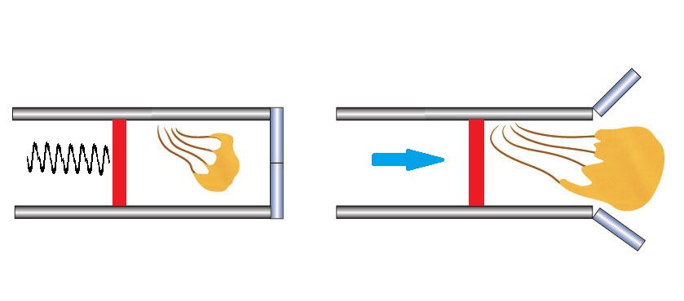

We are going to use spring to deploy the parachute. Parachute deployment system will be operating at mission altitude. So we have to use altimeter and GPS to calculate its altitude and position. When it reaches to the mission altitude, the spring is spread by control system, and pushes the red plate in the picture, and then it helps to release the parachute.

1. 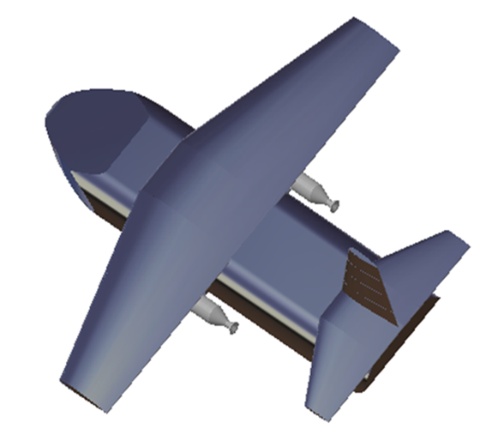Conclusion- R2D2’s configuration

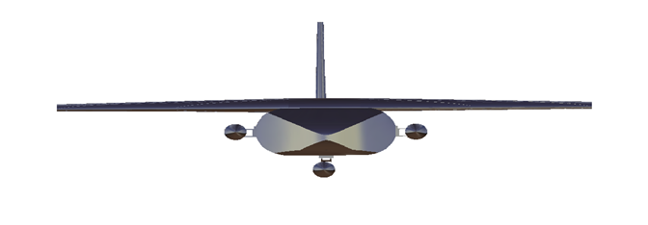

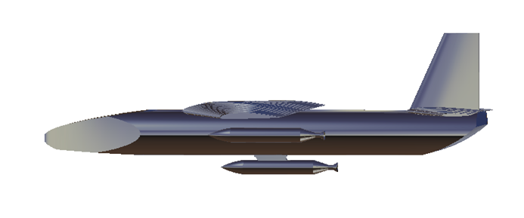R2D2 can deliver supplements very well. People will survive.

1. Reference

≫ DATCOM Manual 2010.

≫ Aircraft Conceptual Design Lecture Notes, 이승수.

≫ Flight Dynamics Lecture Notes, 이승수.

≫ Catia를 이용한 항공기 제도, 김동주, 이도영 공저. 과학기술 (2008)

≫ Start CATIA V5 R19 for Beginners, 김동주. 청담북스 (2014)

≫ CATIA V5의 기초, 김동균 .진샘미디어 (2013)

≫ Rocket Engineering, 노태성.

≫ Fundamental of Aerodynamics